Assignment – 02

# Name – Md. Farhan Ishmam

# Student ID – 180041120

# Department – Computer Science and Engineering

# Course Number - EEE 4484

# **Experiment – 02 (Part – A)**

**Series Clipper Circuit (with Diode and Resistor)**

# Task – A1

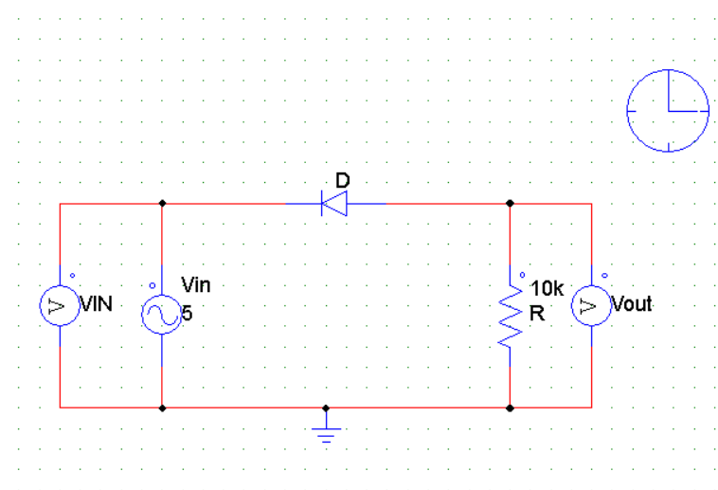

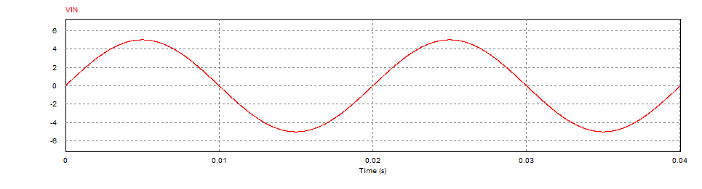

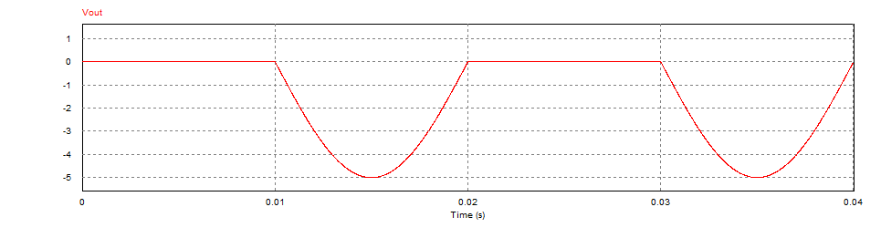

# Task - A2

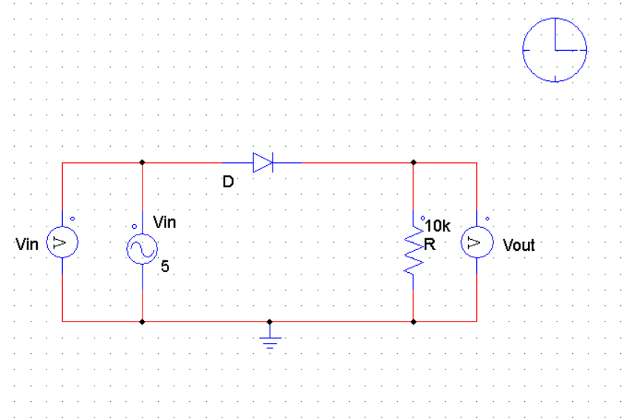

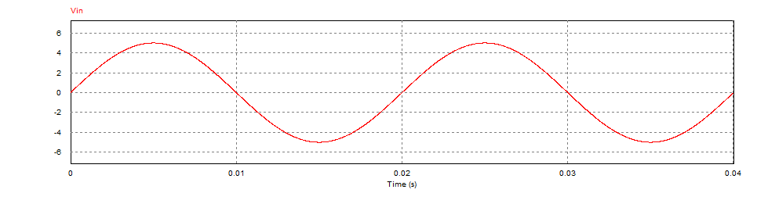

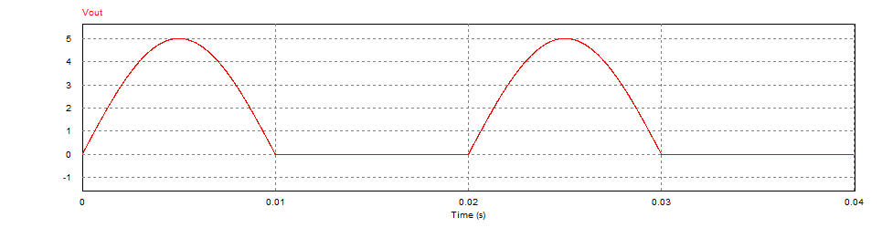

**Parallel Clipper Circuit (with Diode and Resistor)**

# Task - A3

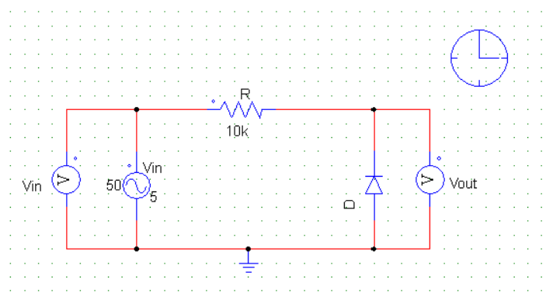



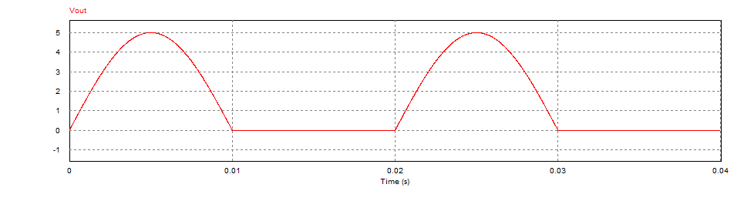

**Biased Series Clipper Circuit (with Diode and Resistor)**

# Task – A4

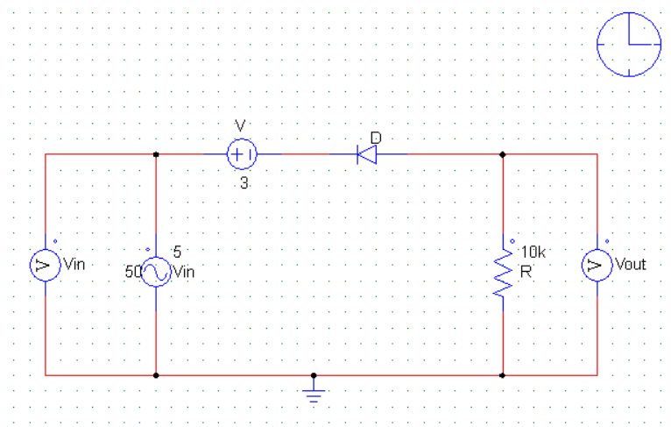



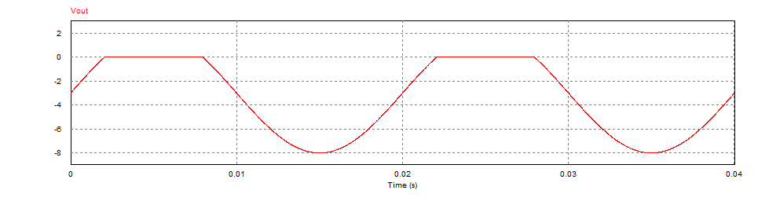

# Task – A5

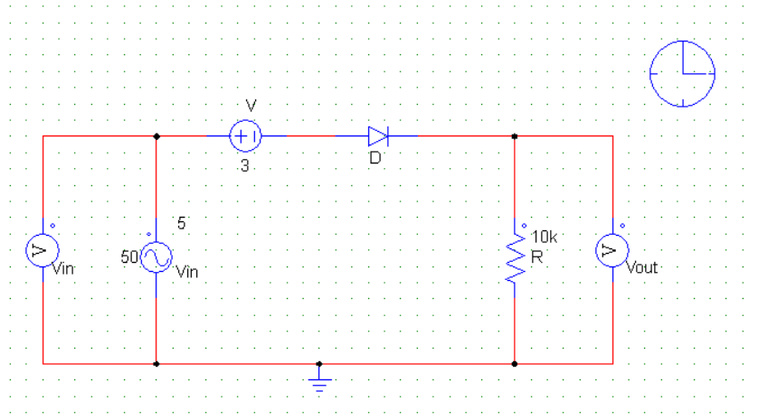



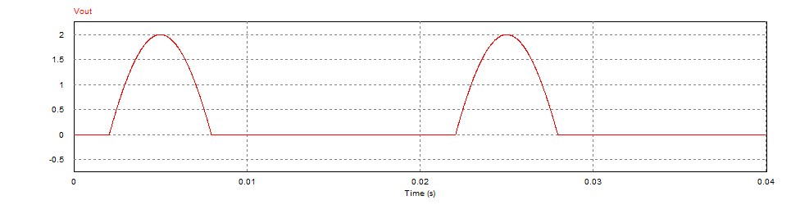

**Biased Parallel Clipper Circuit (with Diode and Resistor)**

# Task – A6

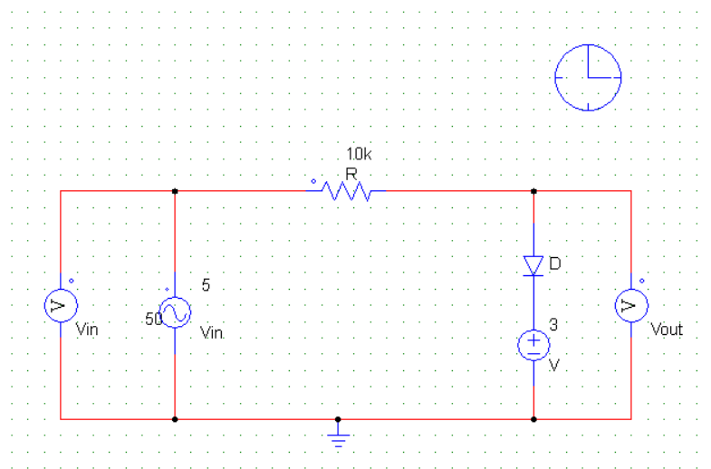



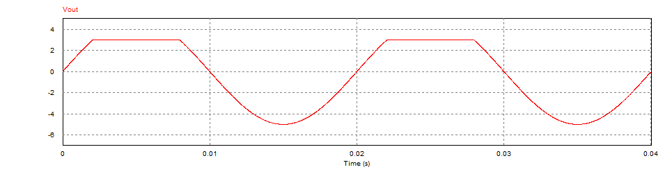

# Task – A7

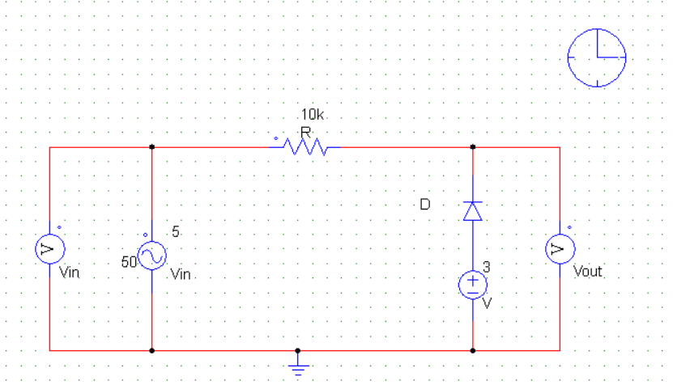



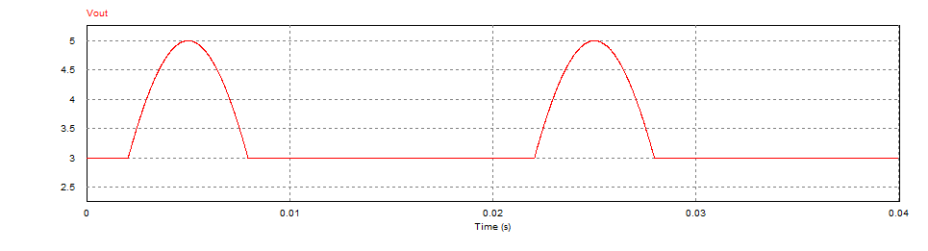

# Task – A8

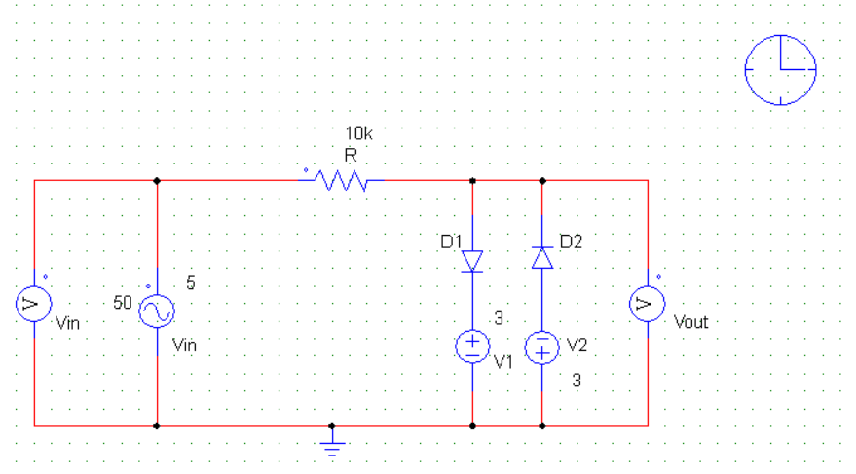



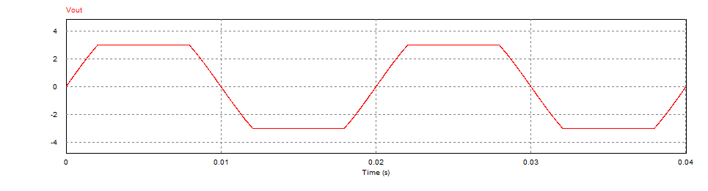

# **Experiment – 02 (Part – B)**

**Series clamping Circuit (with Diode and Resistor)**

# Task – B1

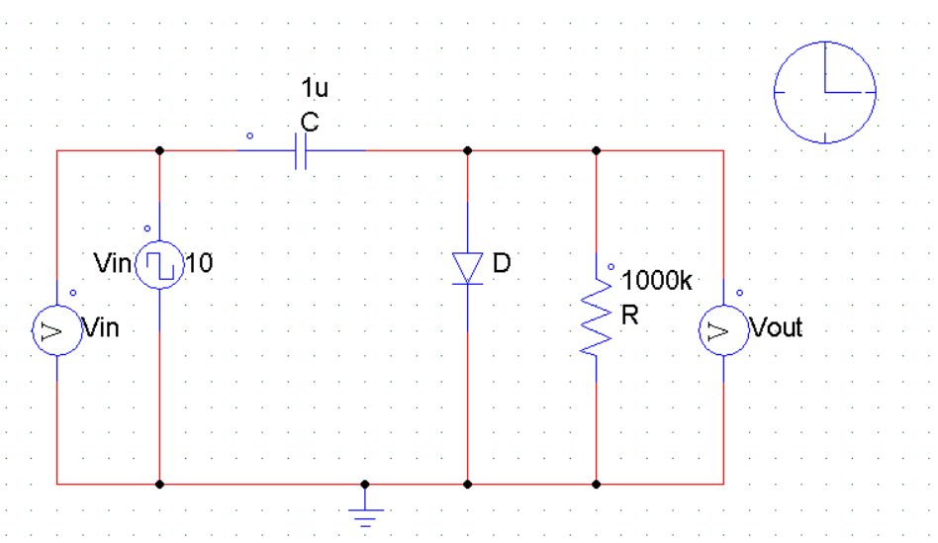

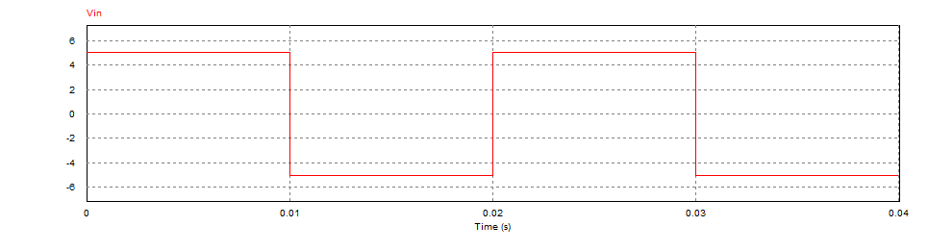

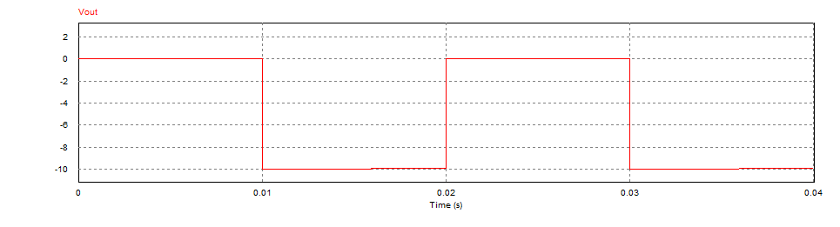

# Task – B2

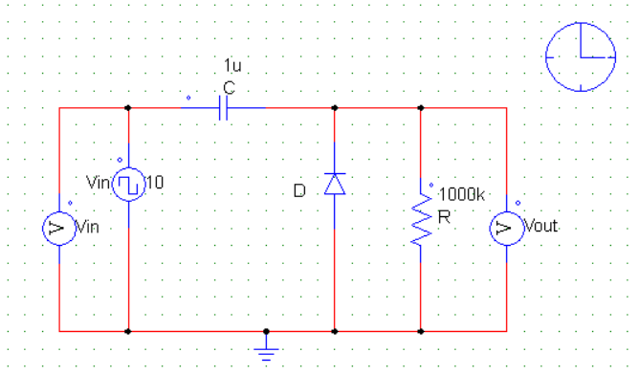



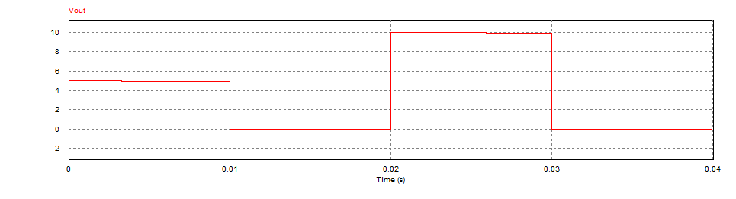

# Task – B3

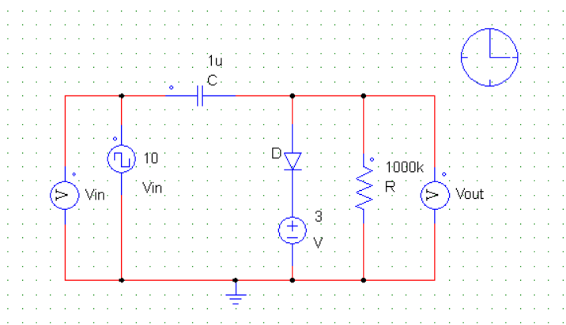



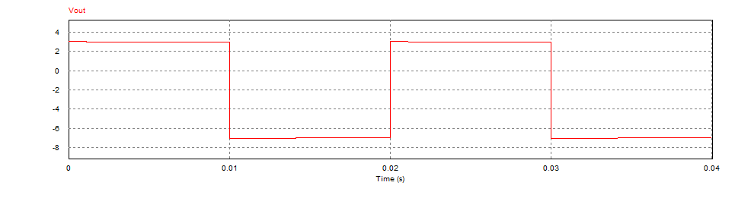

# Task – B4

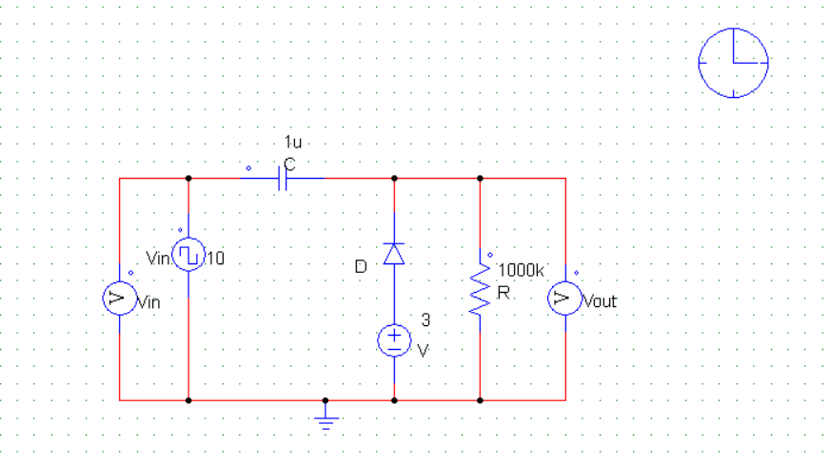



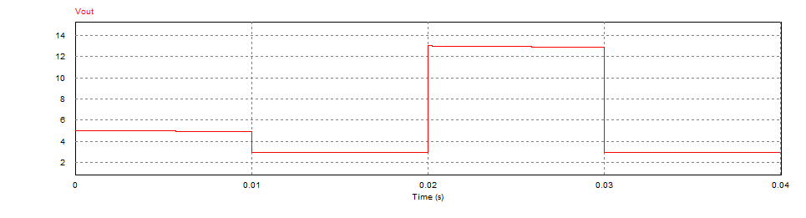

# **Assignment**

# Assignment – 1

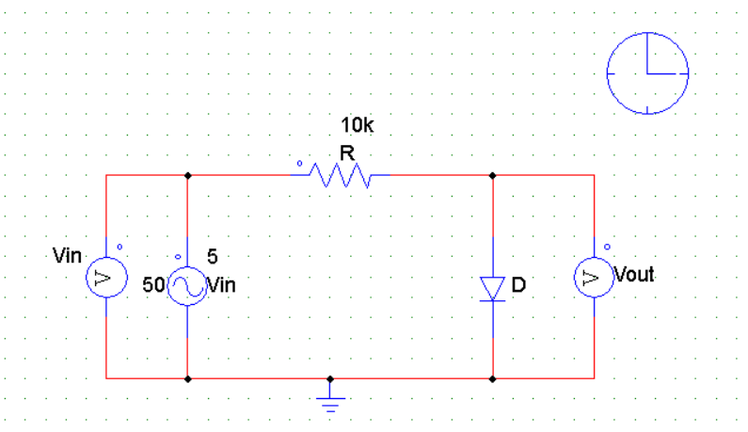



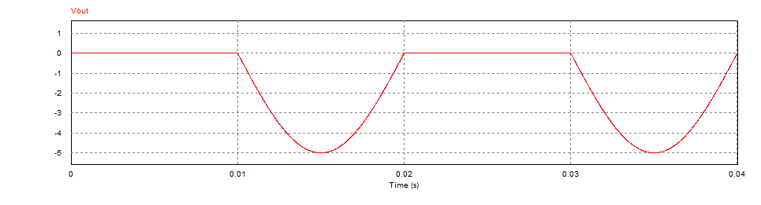

# Assignment – 2

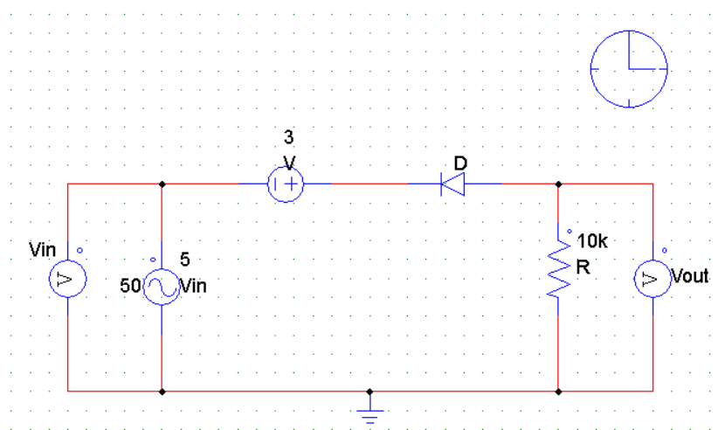



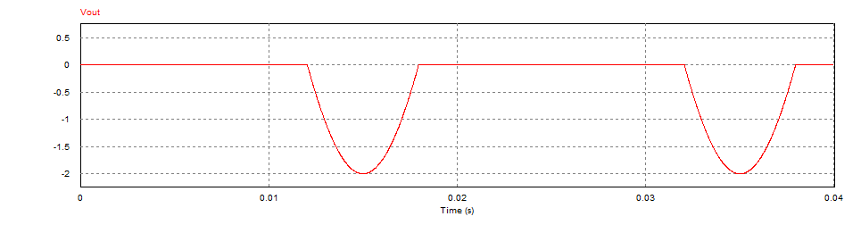

# Assignment – 3

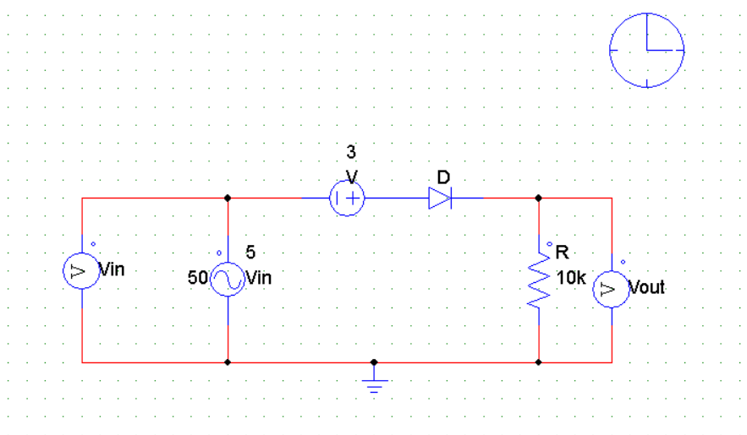



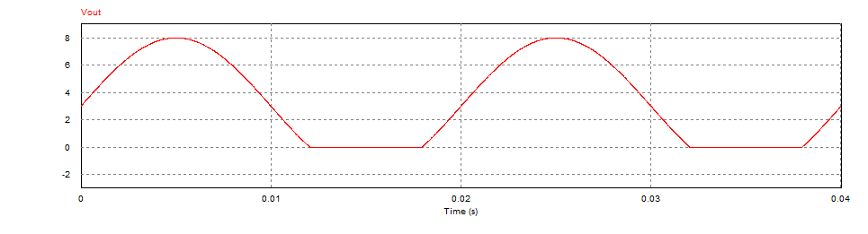

# Assignment – 4

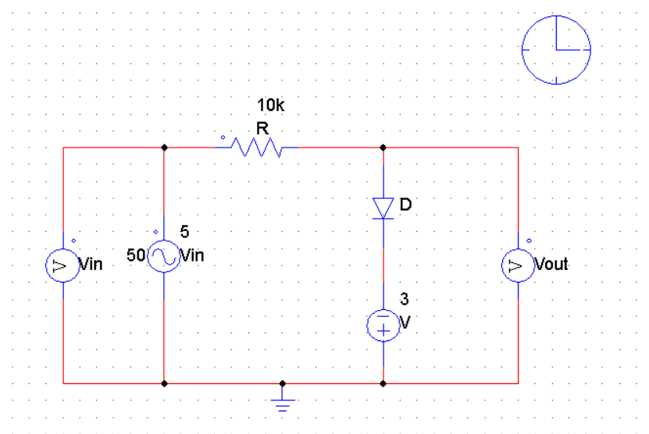



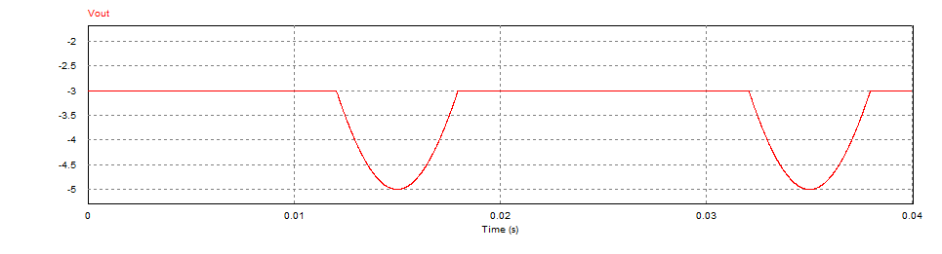

# Assignment – 5

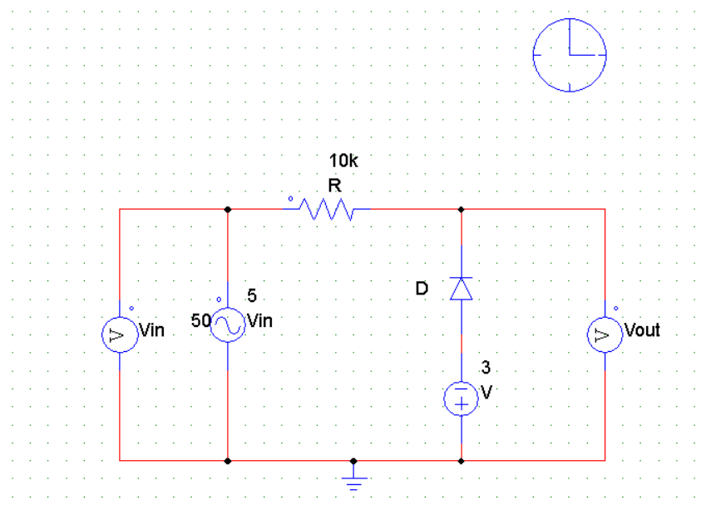

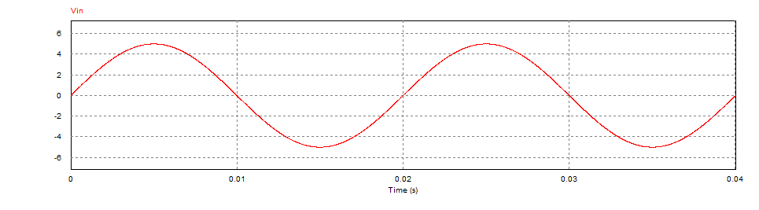

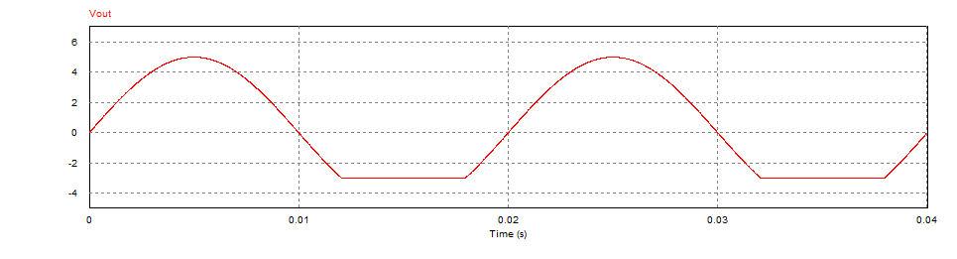

# Assignment – 6

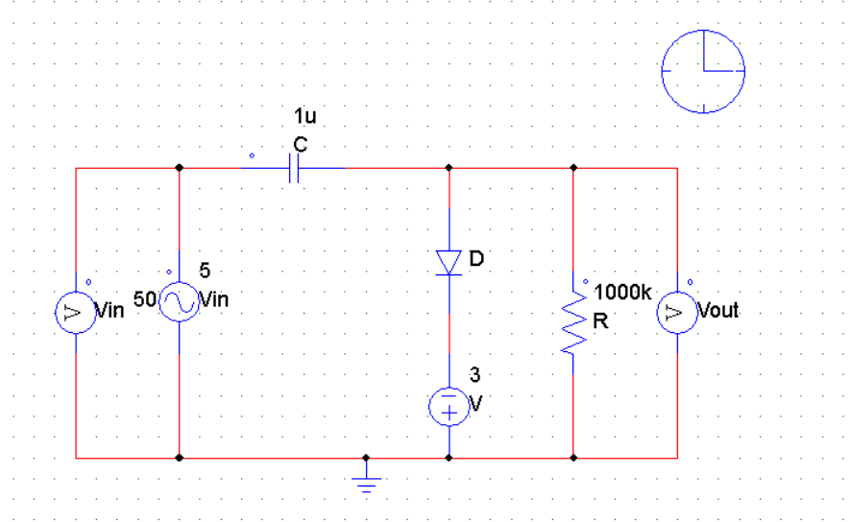



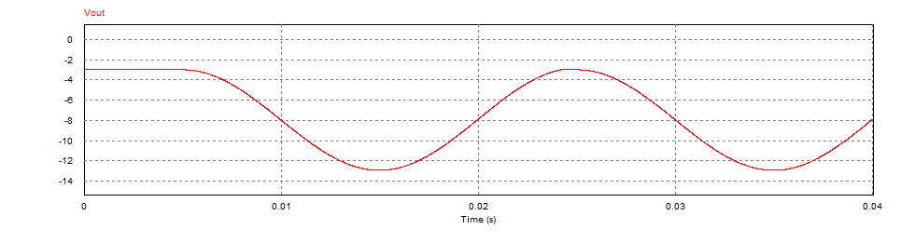

# Assignment – 7

